

`

TOM Integration
Interface Specification
On
Store Details Update
From IDS to CRDB

[S008]

Project BEN Code: | W60416
Author: | Shajitha Mohammed
Date: | 23/04/2007
Version: | 0.2
Status: | Draft
Modified By:
Reviewed By: | Andrew Barker

Change Record

Author | Date | Version | Change Reference, description
Shajitha Mohammed | 20-04-2007 | 0.1 | Draft
Shajitha Mohammed | 18-06-2007 | 0.2 | Draft

Reviewers

Name | Date | Version | Position
Andrew Barker |  | 0.1 | Engagement Architect

At least one reviewer is required.

Sign-Off

By signing this form, I understand and agree with the contents of this document.

Business Owner/Customer | Andrew Barker
Position | Engagement Architect
Signature | <Physical signature or via email approval>
Date | dd/mm/yyyy (<version signed off>)

Distribution List

Name | Date of Issue | Version
Andrew Barker
John Cowper
Jon Braggs
David Onyett
Venkateswara Rao

Document Source
DocShare: UK IT/TOM Integration/Shared Documents

Related Documents

A complete interface specification requires three documents- an Interface Specification, an Information Architecture Context diagram, and a Mapping spreadsheet. This section identifies these documents plus other documents as appropriate.

Mapping spreadsheet
S009-StoreDetailsUpdate(IDStoCRDB) Mappings.xls

Other Reference Documents
Interface 001 Store Details v3.1.doc
Table of Contents
1 Introduction 5
1.1 Purpose of Document 5
1.2 Background 5
1.3 Scope 5
2 Description and Requirements for the End-to-End Interface 6
2.1 Description of the End-to-End Interface 6
2.2 Architecture 6
2.3 Requirements of the End-to-End Interface 6
2.4 Non-Functional Requirements of the End-to-End Interface 7
3 Processing Required in the Extract Stage of the Interface 8
3.1 Scope 8
3.2 Source Message Schema 8
3.3 Message Transport Details 8
4 Processing Required in the SSIS Stage of the Interface 10
4.1 Scope 10
4.2 Package Overview 10
4.3 Data Validation 10
4.4 Filtering 10
4.5 Mapping 10
4.6 Target Message Schema 10
4.7 Message Transport Details 12
4.8 Naming and Configuration 13
4.9 Environment and Security Context 13
4.10 Non-Functional Requirements 13
5 Testing Deliverables 15
6 Deployment 16
7 Assumptions and Outstanding Issues 17
7.1 Assumptions 17
7.2 Outstanding Issues 17
Appendix A Volumes 18
Appendix B Glossary 19
Appendix C Document Control 20

Introduction

Purpose of Document
The purpose of this document is to describe the interfacing requirements to transfer the store details between the IDS to CRDB. The document is of a sufficiently technical nature to allow a developer to build an actual interface. Additionally the document contains detail that might sit logically within a Technical System Design (TSD) document, but is contained here for expediency. There is therefore no associated TSD for this interface.

This interface is for both US and Turkey implementations.

Background
As part of Tesco Operating Model program, there is requirement to bridge the functionalities of enterprise applications including IDS and CRDB. To achieve this functionality, high level process flow architecture has been designed and approved by Tesco’s Enterprise Architecture team. As part of this process flow architecture there is a set of interfaces that has been identified to be developed to transfer store details from IDS into CRDB.

Scope
The Interface Specification covers:

- audit requirements across the interface
- security requirements across the interface
- timing/frequency requirements or constraints
- support requirements
- archiving
- the data format to be used for the interface at each stage (e.g. xml messages)
- the normal processing required at each stage
- recovery from failure required at each stage
- volumes.

Note that it is Tesco strategy to avoid placing any business logic in integration layer processing.

Description and Requirements for the End-to-End Interface

Description of the End-to-End Interface
The interface is a batch extract of store details from IDS using Common Forms and sends it to the CRDB system as a positional Flat file via integration layer.

Architecture
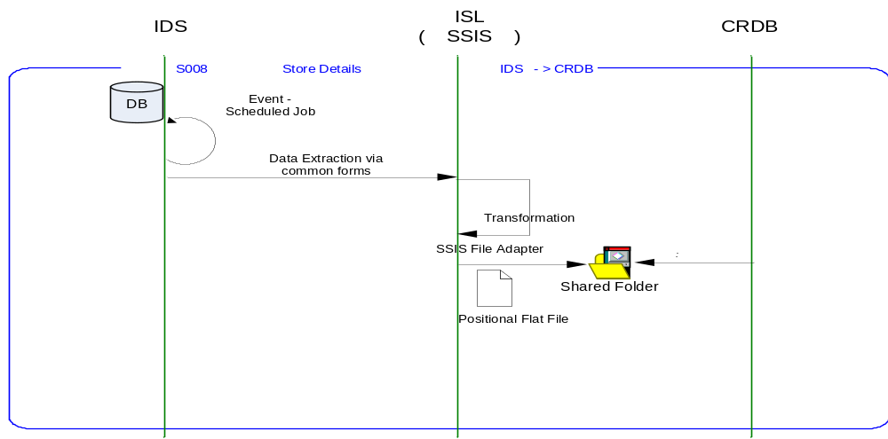

Requirements of the End-to-End Interface
The interface will run once a day, on scheduled basis, and consists of a SQL Server Integration Services package that extracts data from the IDS, and formats it into the target file format.

The interface is meant to run nightly at a pre-configured time which on completion is expected to upload the Store details in a Flat file into shared directory in integration layer.

The interface will make use of the audit and traceability components that are being developed as part of the Operational Framework stream. These components will be pluggable, and will be useable from BizTalk, RTI, and SSIS. At the time of writing (2007-01-20) the components are in design. Although not ready for use, they are included on the Information Architecture Context diagram where their functionality is required. Developers should put a ‘placeholder’ in their code / configurations as appropriate.

Non-Functional Requirements of the End-to-End Interface

Audit Requirements | The interface will use the components provided by the Operational Framework to satisfy audit requirements.
Security Requirements | The interface executes within a secure private domain. There are no additional security considerations required.
Timing/Cut-off Constraints | To be finalised.
Performance Requirements | The interface should be capable of extracting data from IDS using Common Forms, delivering the resulting data to CRDB in form of Flat file before the identified cut-off time. The interface should run on scheduled batch basis.
Reliability and Availability Requirements | The interface-run should be non atomic in nature. Appropriate mechanisms should be in place to raise/alert appropriate parties.
Scalability Requirements | No Scalability requirement. The requirement is to deliver a single extract. It is anticipated that the volume of data transferred will continue to remain within the capability provided by this implementation.
Operational Support Requirements | The scheduled start of the extract job and/or the completion of the target table update should be defined as IMOF events.
Likelihood of Change Requirements | There is no such requirement
Cultural/Global Consideration Requirements | Although multi-byte character set support is not required for US or Turkey, the interface will support multi-byte character sets through integration.
Legal Requirements | N/A
Compliance To Standards Requirements | No compliance exceptions.

Processing Required in the Extract Stage of the Interface

Scope
This section describes the data sources required by this interface and the services used to access the data.
A scheduled batch job/s runs, at a pre-configured time, to extract the store information from IDS. This batch job in turn kicks off a process that executes SQL server Integration Services package and creates a required data-set as a flat file to a shared location in the integration layer. The data is also transformed to the required format within SSIS package

Source Message Schema
The data for this interface resides in the IDS. Common Form Service TOM.Common.Schema.Location is called by the SSI package to extract the store details. The services are exposed as stored procedures and return row sets representing all the details of location and store in the Location Common Form.

Message Transport Details

Feature | Specification | Additional Information
Source System Name | IDS
Source Platform / OS | Windows 2003 Server
Source Physical Location | SQL SERVER 2005
Source Underlying Data Storage Technology | RDBMS
Target System Name | SSIS
Target Platform / OS | Windows 2003 Server
Target Physical Location | SQL SERVER 2005
Target Underlying Data Storage Technology | RDBMS
Transfer Function | HTTP (Put/Post) □  HTTPS (Put/Post) □  Message Queue □  FTP □  File Drop(Windows) □  (XCOM) □  Common Forms ☑
Data Format. | XML □  Delimited □  Positional □  RDBMS ☑
Decryption/Encryption | No
Decompression/Compression | No
Transmission Mode | Synchronous □  Asynchronous ☑  Bulk Data □
Real-time/Scheduled Batch | Not yet decided
Archiving | There is no requirement to archive the messages.
Logging | Log via the Operational Framework.
Error Handling | Not yet decided  Processing should prevent sending of duplicate messages, unless this occurs during recovery from failure.

Processing Required in the SSIS Stage of the Interface

Scope
This section describes the discreet steps within the SSIS package to extract and format data. The target file format is included in this section.

Package Overview
SSIS extracts the store details from IDS using Common Forms, nightly at predefined time. In turn, the data is formatted as per the target CRDB systems file structure and stores the same into the shared directory in integration layer.

Data Validation
N/A

Filtering
There is no filtering requirement.

Mapping
Mapping document will be provided subsequently.

Target Message Schema
Header Record
Column Name | Type | Length | Description
Record Type | Alphanumeric | 2 | Set to '00' for the header record.
Date/Time File Created | Alphanumeric | 14 | File Creation Date
Sequence number | Alphanumeric | 6 | Set to '000000'
Date | Alphanumeric | 8 | System date
File Id | Alphanumeric | 3 | Set to '000'
Filler | Alphanumeric | 14 | Set to spaces
Detail Record
Column Name | Type | Length | Description
Record Type | Numeric | 2 | Set to ‘01’
Branch Number | Numeric | 5 | Store Number
Branch Name | Alphanumeric | 21
Original Store Opening Date | Date | 8
Store Closure Date | Date | 8
Actual Country | Alphanumeric | 1 | Set to space
Actual Format | Alphanumeric | 2
Trailer Record
Column Name | Type | Length | Description
Record Type | Alphanumeric | 2 | Set to '99' for the footer records
Record Count | Alphanumeric | 10 | Number of records (Excluding header & trailer)
Filler | Alphanumeric | 35 | Spaces

Message Transport Details
For messages destined for CRDB system, the following applies.

Feature | Specification | Additional Information
Source System Name | SSIS
Source Platform / OS | SQL Server 2005
Source Physical Location | IDS
Source Underlying Data Storage Technology | RDBMS
Target System Name | CRDB
Target Platform / OS | Windows
Target Physical Location | Configurable
Target Underlying Data Storage Technology | File-Based
Transfer Function | HTTP (Put/Post □  HTTPS (Put/Post) □  Message Queue □  FTP □  File Drop (Windows) □  (XCOM) □  RTI File Adapter □  SSIS File Adopter ☑
Data Format | XML □  Delimited □  Positional ☑  RDBMS □
Decryption/Encryption | No
Decompression/Compression | No
Transmission Mode | Synchronous □  Asynchronous ☑  Bulk Data □
Real-time/Scheduled Batch | RDBMS extract
Archiving | There is no archiving requirement
Logging  Should logs be kept of all actions? For how long should these be stored? | Logging should occur, such that the message can be recreated if necessary.
Error Handling | On fail move the file to the failed transmissions location. The file drop failure will be tracked through IMOF functionality and will be done through a change request.
Target File Location | TOM/SRD/CRDB/ INBOX

Naming and Configuration

SSIS
Package Name: TOM.S008.IDSCRDB.StoreDetailsUpdate
Name | IDSCRDBStoreDetailsUpdate
<Placeholder for other package components/steps>
<Placeholder for other package components/steps>

Environment and Security Context
Account details will be included here once we have visibility of the environments.

Non-Functional Requirements
On successful delivery of the data to the target system, the audit log should be updated via the Operational Framework pipeline component or adapter (to be determined).

In the event of a failure of transformation of data should be written to the failed log database, and an alert should be raised.

Testing Deliverables
This section should contain a list of discrete deliverables. The following table is an illustrative template only. The exact deliverables will depend on the technologies employed in the interface.

Deliverable | Description
TBD <stored proc name> | Common Form Stored Procedure
TBD <stored proc name> | Common Form Stored Procedure
TBD <service name> | Common Form Web Service
TBD <SSIS package name> | Package
TBD <RTI configuration file> | Xml configuration file exported from RTI. For testing, this should contain the configuration required to support this interface only.  For production, configuration should be documented under section 7 Deployment.
TBD <script name> | Unit Test Scripts. Scripts should be provided to:  - create databases (including stored procedures).  - populate with the minimum set of test data to satisfy functional requirements  - notes showing how to use scripts and describing the functions tested.
<installer> | Installers as appropriate to the technology being used.

Deployment

Assumptions and Outstanding Issues

Assumptions
ID | Assumption

Outstanding Issues
ID | Issue | To be addressed by
1 | Timings and cut-off constraints need to be defined. Require input from CRDB.
2 | Destination Shared location to be confirmed
3 | Error handling to be confirmed with respect to archiving process

- Volumes
- Glossary

Acronym | Term | Description
EAI | Enterprise Application Integration | The process of meeting the data requirements of applications by providing a message based transport from disparate data sources across all forms of enterprise technology.
EAI Layer | Enterprise Application Integration Layer | Refers to the integration services provided to implement EAI. In contrast to the EIA Layer for data services. See below.
EIA | Enterprise Information Architecture | Creation of a strategic single view of data across the enterprise.
Interface | Interface | Many definitions exist for 'interface'. In general, 'interface' refers to the link between a data source and a data target. And there are properties of the interface in this context. However more specifically 'interface' refers to one end of a data link, hence the terms source interface and target interface, and both the source interface and the target interface will have specific properties of their own.
RMS | Retek Merchandising System | Retek Merchandising System is getting installed for TESCO Merchandising operations in US. This system will governs the Merchandising operations; Receive base Master & Transaction data and from other systems and Provide data to next level of operation system as part of Retail systems chain.
IDS | Information Data Store | A store of data, logically residing in the EIA layer, that provides an authoritative single view of a discrete data component specific to the enterprise. Eg: Product, Store, etc. IDS's reside in the EIA Layer, and are accessed through the EAI Layer.
IMOF | Integration Management Operational Framework | IMOF is a framework which is pluggable to any Biztalk, RTI and SSIS for alerting, exception handling, defining rules, scheduling etc

- Document Control
Change Record

Author | Date | Version | Change Reference, description
Shajitha Mohammed | 19-April-2007 | 0.1D | Draft

Related Documents

Author | Date | Version | Title
Andy J Smith | 08/09/2006 | v3.1 | Interface 080 Product Description

Distribution

Name | Position | Approver/Contributor/Other
Andrew Barker | Engagement Architect
John Cowper | Solution Architect
Jon Braggs | Enterprise Architect
David Onyett | Project Lead
Venkateswara Rao | Delivery Manager

